Deep Reinforcement Learning
Topic Covered in the lab sheet : Multi-Armed Bandits and MDP Foundations
[ This lab sheet is accompanied by Python files, links to datasets ]

1. Introduction
Reinforcement Learning (RL) studies how an agent interacts with an environment to maximize cumulative rewards. One of the simplest and most foundational problems in RL is the Multi-Armed Bandit (MAB) problem.
The name originates from slot machines (“one-armed bandits”) in casinos. Each machine has an unknown probability of reward, and the player must decide which machine to play in order to maximize total winnings.
The Multi-Armed Bandit problem captures the fundamental dilemma in RL:
• Exploration – Trying different actions to gather information.
• Exploitation – Selecting the best-known action to maximize reward.
This exploration–exploitation trade-off lies at the heart of reinforcement learning.
This lab introduces the Multi-Armed Bandit problem through a healthcare-inspired scenario and connects it to the broader framework of Markov Decision Processes (MDPs).

2. The Problem:
Consider an Intensive Care Unit (ICU) treating critical patients.
Doctors must select one of several oxygen dosage levels for each patient. However:
- The true effectiveness of each dosage is unknown.
- Trying random dosages may risk patient health.
- Sticking to one dosage may ignore better alternatives.
Each oxygen dosage level is treated as a bandit arm.
When a dosage is administered:
- If the patient stabilizes within 24 hours → Reward = 1
- If no improvement → Reward = 0
Objective:
Maximize the total number of stabilized patients over time.
Mathematical Formulation of the Multi-Armed Bandit
Let:
- k = number of arms (dosage levels)
- A = {1, 2, ..., k}
- Rt = reward at time t
- At = action selected at time t
- q*(a) = true mean reward of arm a
Each arm has an unknown reward distribution:
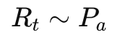
with expected value:
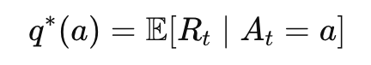
The goal is to maximize cumulative reward:
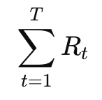
or equivalently maximize expected cumulative reward:
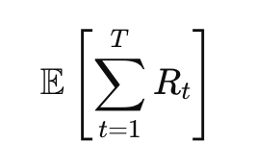
Since true values q*(a) are unknown, we estimate them.
Let:
- Q_t(a) = estimated value of action a at time t
- N_t(a) = number of times action a selected up to time t
Using sample average method:
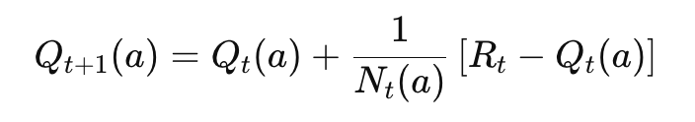
This is an incremental mean update rule.
Interpretation:
- If reward > estimate → increase estimate
- If reward < estimate → decrease estimate
Policies for Multi-Armed Bandits

Greedy Policy
Select the action with highest estimated value:
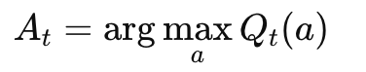
Advantage: Maximizes immediate reward
Disadvantage: No exploration, May get stuck on suboptimal arm

ε-Greedy Policy
With probability ε → Explore
With probability (1 − ε) → Exploit
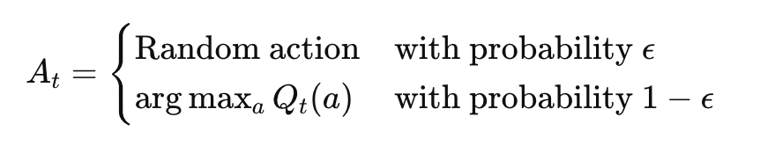
Exploration ensures all arms are eventually tried.

Bandits as Special Case of MDP
An MDP consists of:
States
Actions
Transition probabilities
Rewards
In MAB:
Only one state
No transitions
Immediate rewards only
Thus: Bandit ⊂ MDP

3. Learning Outcomes
After completing this lab, you will be able to:
• Mathematically formulate a bandit problem
• Derive incremental update rules
• Implement Greedy and ε-Greedy policies
• Analyze exploration–exploitation trade-off
• Connect Bandits to MDP foundations
• Understand why Bellman equations are not required for bandits

4. Implementation Roadmap
Step 1: Define number of dosage levels
Step 2: Define true reward probabilities (hidden)
Step 3: Implement reward simulation
Step 4: Implement Greedy policy
Step 5: Implement ε-Greedy policy
Step 6: Track cumulative rewards
Step 7: Compare policies
Step 8: Discuss transition to MDP

8. How to Open and Execute the Notebook
- Open the provided notebook in Colab or Jupyter.
- Install required libraries (if needed).
- Execute cells sequentially using Shift + Enter.
- Observe environment rendering.
- Modify parameters and experiment.

6. Suggested Activities for Students post the completion of this labsheets
To reinforce understanding, students should attempt:
- Increase number of arms to 10.
- Compare ε = 0.01 vs 0.1 vs 0.3.
- Introduce non-stationary rewards.
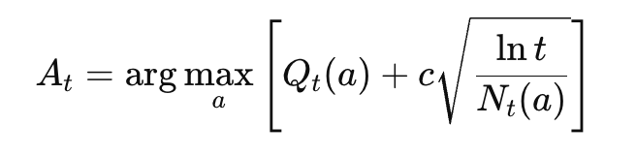
- Implement Upper Confidence Bound (UCB):
- Implement Thompson Sampling.
- Convert scenario into MDP by introducing patient health states.

7. Summary
This lab introduces the Multi-Armed Bandit problem as a foundational reinforcement learning setting.
Key insights:
• Exploration–exploitation trade-off
• Incremental value estimation
• Policy design
• Bandits as special case of MDP
Understanding bandits is essential before studying:
• Bellman equations
• Dynamic Programming
• Q-Learning
• Deep Q Networks

